October 15, 2007

Name
Address_1
Address_2
City, State Zip

Dear Name:

A moment ago you should have received a survey geared especially for you, the young alumni of North Carolina Central University. We are seeking your interests and concerns about NCCU as well as personal information to assist with the upkeep of our database. Sadly, we have yet to hear from you.

If you would, please take a few minutes to complete the enclosed survey. Your answers will help us to do what is needed to better help us serve you. This survey can also be completed online at http://web.nccu.edu/forms/alumni/youngalumnisurvey.shtml.

Keep in mind that you will be entered into a drawing to win a Palm Z22 Personal Organizer if your completed survey is received by Wednesday, October 31, 2007.

Thank you again for your time and efforts. Your response will help us serve you better. We look forward to hearing from you.
Sincerely,
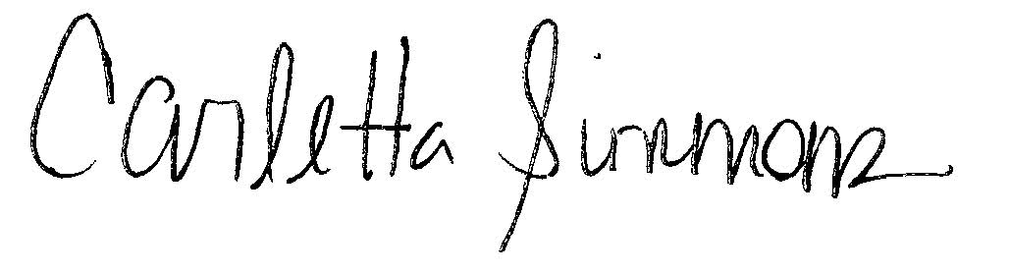
Carletta Simmons
Associate Director of Annual Giving

