August 27, 2007

«Primary_Addressee»
«Preferred_Address_Line_1»
«Preferred_Address_Line_2»
«Preferred_City__State» «Preferred_ZIP»

Dear «Primary_Salutation»,

Where have you been? It’s been a while since we’ve heard from you and we miss you. Things just haven’t been the same without you. We would like to update your records and learn your opinion on some program ideas we are considering here at NCCU.

Win a prize! Take a few minutes to complete the enclosed survey and return it back to us in the envelope provided and your name will be entered into a drawing to win a Palm Z22 Personal Organizer! You also have the option to complete this survey online at http://web.nccu.edu/forms/youngalumnisurvey.php or fax it to (919) 530-7921.

All completed surveys must be received in our office by Wednesday, October 31, 2007 in order to be eligible for the prize. The winner will be posted on the NCCU Annual Giving webpage: http://www.nccu.edu/NCCU/giving/annual/annualfund.html.
.
Thank you in advance for your time and effort. Your responses will help us serve you better. We look forward to hearing from you.
Sincerely,
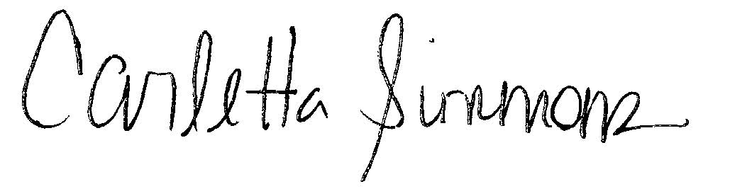
Carletta Simmons
Associate Director of Annual Giving

