October 20, 2000

«Outside_Salutation_Line_1»
«Outside_Salutation_Line_2»
«Address_Line_1»
«Address_Line_2»
«Address_Line_3»
«City», «State» «ZIP»

Dear «Inside_Salutation»:
I am writing you today to ask that you renew your support to the Fund for Syracuse for the 2000-2001 Annual Giving campaign. While you have requested that our students not phone you, I would like to share some of SU’s recent successes, and how your generosity has made a difference.
Last year, alumni, parents, and friends helped raise a record setting $5,583,000 in spendable resources through the efforts of the Fund for Syracuse. You were part of the nearly 28,000 individuals who participated, making 1999-2000 our most successful year to date. Your financial support created new and better educational opportunities for our students, and had a direct impact the quality of the Syracuse experience on many levels:
- 68% of our classes contain 20 or fewer students. In September, U.S. News & World Report named SU as one of the top national universities offering a consistently intimate class size;
- Existing learning communities in the School of Management and the Honors Program have been enhanced, and three new ones were established – Multicultural Living (MLLC), Women in Science and Engineering (WISE), and Leadership Challenge; and
- New initiatives are being formulated to support the recruitment, retention, and professional development of faculty members who aspire and attain the highest standards in teaching and research.
Efforts like these have helped improve Syracuse University’s first-year student retention rate to 91% – strong evidence of our effort to be the student-centered research institution in the country. Your gift not only benefits today’s students, by creating the best possible environment for learning, but also benefits you – by improving the value of your degree.
We can all be proud of SU’s accomplishments – and your role in them - as a reflection of our commitment to the vision of our alma mater. Please join me and our other fellow alumni who will again help continue the tradition of academic excellence at Syracuse University this year.

Sincerely,
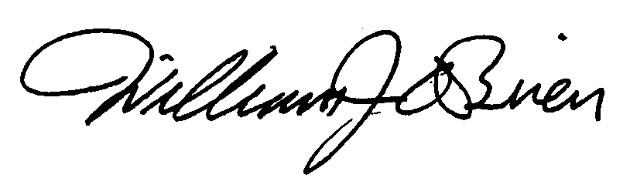

William J. O’Brien ‘69
Executive Director of Development
Annual Giving Programs

PS Please use the enclosed card to let us know if you would like to change your phone status, or if you need further information. Your comments, as well as your gift, are welcomed.

