May 2000

Dear Ms. Sample:

Final exams are over, the packing is done, and a group of promising new graduates began the next chapter of their lives, following the 146th commencement at Syracuse University. Family, faculty, and friends joined these young alumni in celebrating this milestone, and their part in it. You, too, have played a role in our graduates’ success – through your generous support for the Fund for Syracuse.

Your gift helped provide scholarships, new library resources, and access to state-of-the art technology – creating an environment that supports our vision of becoming the nation’s leading student-centered research university. You have given the men and women of the Class of 2000 the strong foundation to become leaders, not only in their chosen professions, but in our communities as well.

Thank you for your past support to Syracuse University. As our fiscal year draws to a close on June 30, please renew your annual gift to the Fund for Syracuse, and join the thousands of alumni, parents, and friends who have already joined us this year. Your generosity will help perpetuate the tradition of academic excellence for today’s students, and tomorrow’s graduates.

Sincerely,
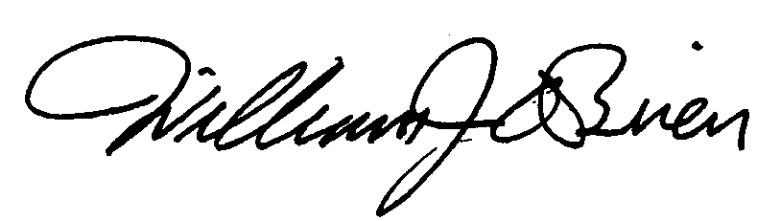

William J. O’Brien ’69
Executive Director of Development
Annual Giving Programs

