Class of 2003
Senior Gift Committee

Robert Capecchi
Class Agent
Sarah Slivinski
Courtney Lind
Genevieve Williams

Brad Behrmann
Andrea Blimling
Jennifer Dieter
Nicole Dubruiel
Natalie Fleming
Jennifer Foth
Sam Nelson Garber
Holly Herbert
Jonathan Hinke
Laura Houser
Jennifer Nihart
Chanda Thapa
Maraty Theinpeng
Laura Zuege
March 20, 2003
Susan XXXXX
XXX Turnbridge Circle
Naperville, IL XXXXXX
Dear Susan,
On behalf of Lawrence University, I would like to thank you for your generous gift of $50 in support of the Senior Class Gift campaign. Please know that your Lawrence Fund gift will be put to good use in advancing the teaching and learning which is the hallmark of the Lawrence Difference
Present and future Lawrentians will remember the generosity of the Class of 2003 when they learn of our efforts meeting the college’s needs through ongoing unrestricted support to The Lawrence Fund. These gifts given by the Lawrence community perpetuate the tradition of offering a quality education to all Lawrentians.
Once again, thank you for supporting the Senior Class Gift campaign. Enclosed is your incentive gift. Your Senior Class gift is an important first step in what we hope will be a lifetime of alumni philanthropy. Best wishes as you start your life as a Lawrence alumna!
Sincerely,
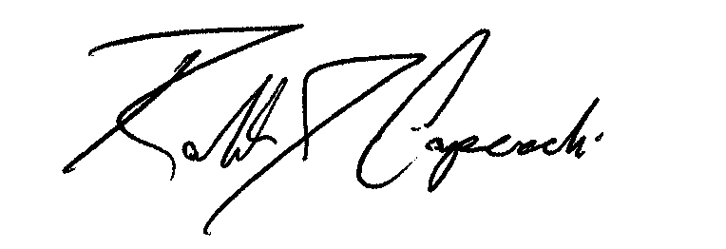
Robert Capecchi
Class Agent

